15) Write a program to perform the following operations:

a) Insert an element into an AVL tree

b) Delete an element from an AVL tree

c) Search for a key element in an AVL tree

PROGRAM:

#include <stdio.h>

#include <stdlib.h>

struct Node {

int key;

struct Node \*left;

struct Node \*right;

int height;

};

int max(int a, int b);

int height(struct Node \*N);

struct Node \*newNode(int key);

struct Node \*rightRotate(struct Node \*y);

struct Node \*leftRotate(struct Node \*x);

int getBalance(struct Node \*N);

struct Node \*insert(struct Node \*node, int key);

struct Node \*minValueNode(struct Node \*node);

struct Node \*deleteNode(struct Node \*root, int key);

void preOrder(struct Node \*root);

struct Node \*search(struct Node \*root, int key);

int max(int a, int b) {

return (a > b) ? a : b;

}

int height(struct Node \*N) {

if (N == NULL)

return 0;

return N->height;

}

struct Node \*newNode(int key) {

struct Node \*node = (struct Node \*)malloc(sizeof(struct Node));

node->key = key;

node->left = NULL;

node->right = NULL;

node->height = 1;

return node;

}

struct Node \*rightRotate(struct Node \*y) {

struct Node \*x = y->left;

struct Node \*T2 = x->right;

x->right = y;

y->left = T2;

y->height = max(height(y->left), height(y->right)) + 1;

x->height = max(height(x->left), height(x->right)) + 1;

return x;

}

struct Node \*leftRotate(struct Node \*x) {

struct Node \*y = x->right;

struct Node \*T2 = y->left;

y->left = x;

x->right = T2;

x->height = max(height(x->left), height(x->right)) + 1;

y->height = max(height(y->left), height(y->right)) + 1;

return y;

}

int getBalance(struct Node \*N) {

if (N == NULL)

return 0;

return height(N->left) - height(N->right);

}

struct Node \*insert(struct Node \*node, int key) {

if (node == NULL)

return newNode(key);

if (key < node->key)

node->left = insert(node->left, key);

else if (key > node->key)

node->right = insert(node->right, key);

else

return node;

node->height = 1 + max(height(node->left), height(node->right));

int balance = getBalance(node);

if (balance > 1 && key < node->left->key)

return rightRotate(node);

if (balance < -1 && key > node->right->key)

return leftRotate(node);

if (balance > 1 && key > node->left->key) {

node->left = leftRotate(node->left);

return rightRotate(node);

}

if (balance < -1 && key < node->right->key) {

node->right = rightRotate(node->right);

return leftRotate(node);

}

return node;

}

struct Node \*minValueNode(struct Node \*node) {

struct Node \*current = node;

while (current->left != NULL)

current = current->left;

return current;

}

struct Node \*deleteNode(struct Node \*root, int key) {

if (root == NULL)

return root;

if (key < root->key)

root->left = deleteNode(root->left, key);

else if (key > root->key)

root->right = deleteNode(root->right, key);

else {

if ((root->left == NULL) || (root->right == NULL)) {

struct Node \*temp = root->left ? root->left : root->right;

if (temp == NULL) {

temp = root;

root = NULL;

} else

\*root = \*temp;

free(temp);

} else {

struct Node \*temp = minValueNode(root->right);

root->key = temp->key;

root->right = deleteNode(root->right, temp->key);

}

}

if (root == NULL)

return root;

root->height = 1 + max(height(root->left), height(root->right));

int balance = getBalance(root);

if (balance > 1 && getBalance(root->left) >= 0)

return rightRotate(root);

if (balance > 1 && getBalance(root->left) < 0) {

root->left = leftRotate(root->left);

return rightRotate(root);

}

if (balance < -1 && getBalance(root->right) <= 0)

return leftRotate(root);

if (balance < -1 && getBalance(root->right) > 0) {

root->right = rightRotate(root->right);

return leftRotate(root);

}

return root;

}

void preOrder(struct Node \*root) {

if (root != NULL) {

printf("%d ", root->key);

preOrder(root->left);

preOrder(root->right);

}

}

struct Node \*search(struct Node \*root, int key) {

if (root == NULL || root->key == key)

return root;

if (root->key < key)

return search(root->right, key);

return search(root->left, key);

}

int main() {

struct Node \*root = NULL;

root = insert(root, 10);

root = insert(root, 20);

root = insert(root, 30);

root = insert(root, 40);

root = insert(root, 50);

root = insert(root, 25);

printf("Preorder traversal of the constructed AVL tree is: \n");

preOrder(root);

root = deleteNode(root, 30);

printf("\nPreorder traversal after deletion of 30: \n");

preOrder(root);

struct Node \*result = search(root, 40);

if (result != NULL)

printf("\nKey 40 found in the AVL tree.");

else

printf("\nKey 40 not found in the AVL tree.");

return 0;}

INPUT:

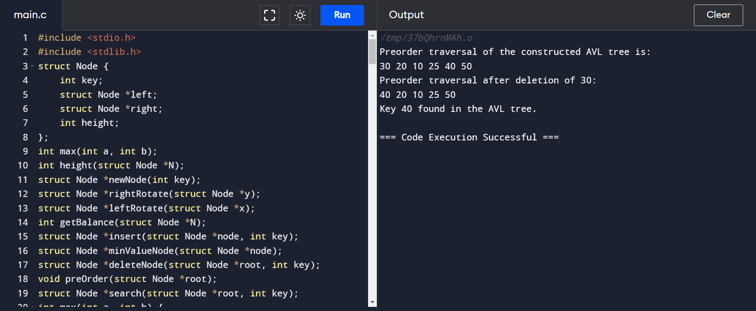

OUTPUT:

